**USER STORIES**

***CUSTOMERS***

As a customer, I should be able to access the web page using the URL

As a customer, I should be able to view the menu

As a customer, I should be able to order the menu

***ADMIN***

As an admin, I should be able to view the order menu

As an admin, I should be able to view a particular order

As an admin, I should be able to resolve orders attended to

As an admin, I should be able to log in and log out

**FLOW CHART**

**ADMIN’S ACTION**

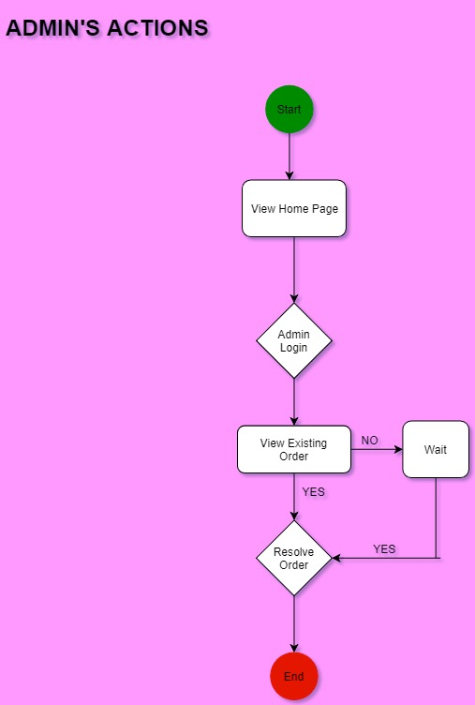

**CUSTOMER’S ACTIONS**

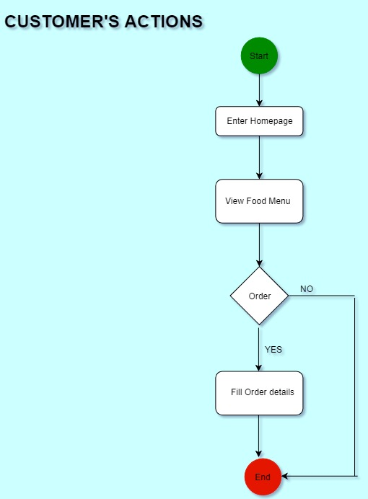

**MOCKUP**

**Home Page**

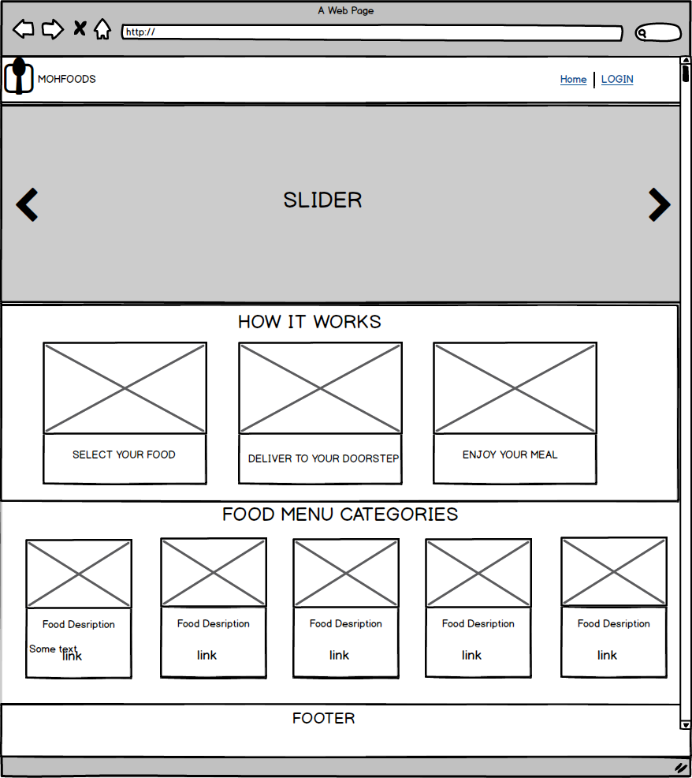

**Admin Login**

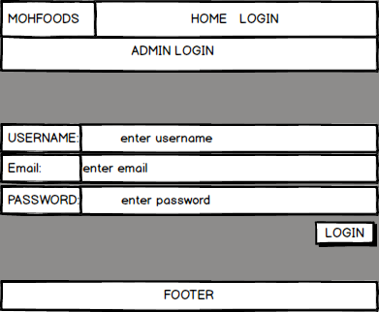

**Order Page**

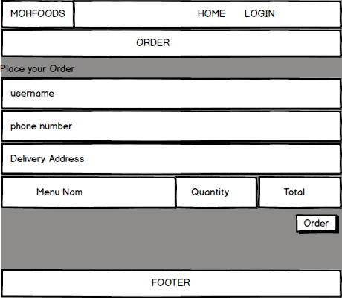

**View All Order**

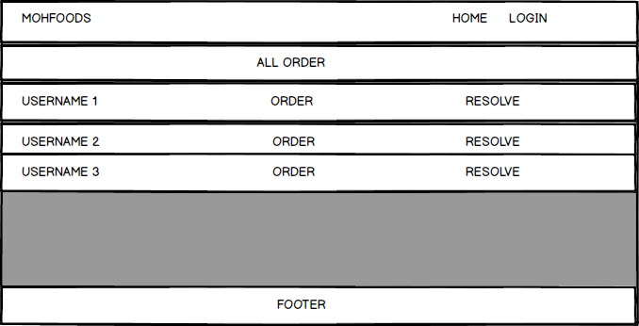

**View A Particular Order**

